Snapshot Differential Algorithm For Data Analysis Using Map Reduce Technique

D. A. Phalke, Sachin Bhalekar, Ankita Deore, Saurabh Dudhe, Dhiraj Khodade

Department of Computer Engineering
D. Y. Patil College of Engineering

Akurdi, Pune, India.

Abstract— The competition in retail stores is increasing in today’s world. In order to sustain the competition, better analysis systems are needed to understand market scenarios and customer views. A better understanding of what and why the customers are purchasing provides the basis for business planning from strategic level to operational level. Massive amount of data that is generated at retail stores needs to be analyzed. This paper presents a system which extracts valuable information from transaction logs and make this information available to analysts. The system provides tools for analysis based on sales, customer, product and then the results of these analysis can be used for decision making for retail stores. In this system data is analyzed using snapshot differential algorithm and association rules. In order to improve the efficiency of massive data processing this system uses hadoop platform.

Keywords— Mapper, Reducer, Distributed computing, Snapshot differential algorithm, Data mining.

I. INTRODUCTION

Analysis of massive data generated at retail stores supports variety of business related applications such as inventory management, customer relationship management, marketing promotions and product placement. But analyzing the huge data is not a simple task it requires high performance system. The proposed system ‘Snapshot differential algorithm for data analysis using map reduce technique’ solves the problem of performance and scalability. In our system data is analyzed using Snapshot differential algorithm. It takes huge computation for analysis of large snapshots . Therefore we are using hadoop cluster which divides the task into subtasks. In hadoop cluster master node will divide the task into different subtasks using mapper and distribute this subtask among several child nodes. Child node individually processes the given subtask and returns result to the parent node[6].

II. ARCHITECTURE OF THE PROPOSED SYSTEM

The proposed system solves the problem of performance and scalability. In hadoop cluster master node will divide the task into different subtask using mapper and distribute this subtask among several child nodes. Child node individually processes subtask and result produced at each node is sent to master node using reducer which eventually sends results to oracle DB. The user can see graphical representation of analysis reports through web application.

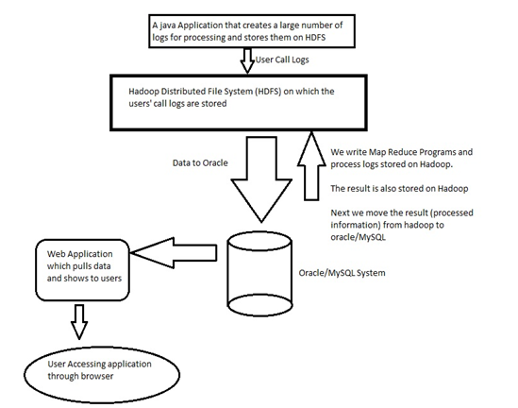

Fig. 1 System Architecture

III. THE MAP/REDUCE FRAME OF HADOOP

The Apache Hadoop project develops open-source software for reliable, scalable, distributed computing. We can easily develop distributed program and fully make use of the benefit of Cluster with greater computing power. Hadoop is reliable because it considers the fact that the data may be lostAnd wrong. So Hadoop keep several replications in the cluster in order to deal with the collapse of certain machine. Hadoop is efficient, because it can parallelly calculate in different machines. Hadoop is flexible, and we can add a new machine into cluster easily in order to deal with more data. In addition, Hadoop not only can be used in big servers but also in common computers. We can easily build Hadoop cluster and use it[6]. The Frame of Map/Reduce contains Mapper and Reducer. Mapper reads a record from file and maps the record < k, v> into certain partition according to the key value k. Reducer is responsible for dealing with the records with the same key and generating the result.

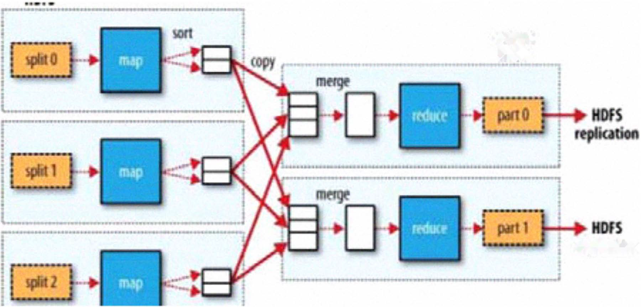

Fig. 2 Principle of Map-Reduce

From the above figure, the idea of Map/Reduce deals with massive data is, dividing this massive data into several pieces
and deal with these pieces respectively. The most important benefit of this idea is that we can process data independently and concurrently[6,7].

- Implementation of Mapper

The file system (HDFS) of Hadoop can split a big file into a block. Generally, the size of the block is 64M. The Mapper can get one block from the file system and read the records in this block automatically. In some cases, we can provide a class to tell system how to read these records. After reading a record, the Mapper use hash function to map the record into a certain partition. The key code is below.

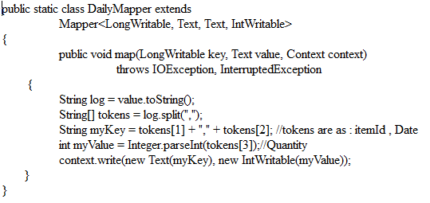

Fig. 3 Code of Mapper

- Implementation of Reducer

The Hadoop will transport the records from partitions which are generated by Mapper to Reducer. A Reducer will get a partition. Then, we provide a class to specify how to sort these records. After sorting records, records with the same key will be next to each other. Finally, Reducer will call function "reduce" which will iterate the records with the same key. We must determine how to generate delta with it. The key code is below.

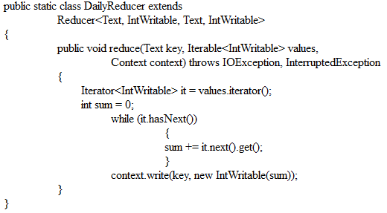

Fig. 4 Code of Reducer

IV. SNAPSHOT DIFFERENTIAL ALGORITHM

View source snapshot as a file containing a set of distinct records,

{R1,R2,R3,R4,R5,R6,.........,Rn}

where Ri denotes a record. Ri is of the form <Ki,Bi>, where ki is key and Bi is rest of the record representing one or more fields.

For snapshot differential problem we have two snapshot F1 and F2 and output is F_{out} i.e. of the form

{R1,R2,R3,R4,R5,R6,.........,Rn}

where each record Ri is of the the form <Ki,Bi>. The goal of snapshot differential algorithm is to calculate delta[2,5].

F_{out}= (F₁-F₂) U (F₂-F₁)

V. ASSOCIATION RULE

Let,
I={I1,I2,I3.........In} n binary attributes.

D={T1,T2..........Tm} be a set of transaction

Each transaction in D has unique ID and contains subset of items in I. Association rule is defined as an implication of the form X->Y, where X,Y is subset of I and X intersection Y is NULL set[8].
Support :
The support (supp) of an item set X is defined as the proportion of transactions in the data set which contains the item set.
Supp (X) = (transactions containing item set ) ÷ (total transactions)

Confidence :
Confidence measures the reliability of the inference made by rule
Conf(X->Y) = supp(X U Y) ÷ supp(X)

Lift :
Lift gives us increase in probability of Y given X
Lift(X->Y) = supp(X U Y) ÷ supp(Y) x supp(X)

- Lift > 1 , then X and Y are positively correlated.
- Lift < 1 , then X and Y are negatively correlated.
- Lift = 1 , then X and Y are independent.

To illustrate the concepts, we use a small example from the supermarket domain. The set of items is I = {milk, bread, butter, beer} and a small database containing the items.

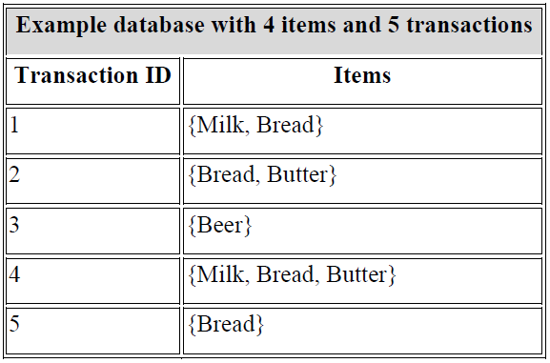

Fig. 5 An example of market transactions

This data can be translated into binary format as shown in table 2 where each row corresponds to a transaction and each column corresponds to an item. If the item is present in the transaction, 1 is coded and 0 for otherwise.

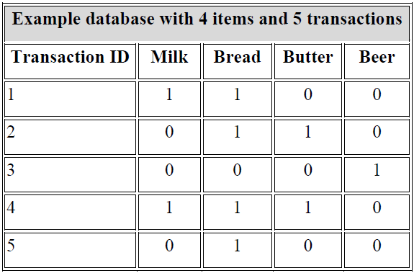

Fig. 6 Binary representation of transaction data

Fig 7 shows the count of co-occurrences of 2 distinct items appearing in the same transactions. The count of co-occurrences between 2 distinct items is a measure of interestingness and may signify correlation (A->B) which goes like this: If A is purchased, then B is also purchased. In this small example, we can draw some preliminary conclusions and say that bread is the most purchased item and is usually bought together with milk or butter.

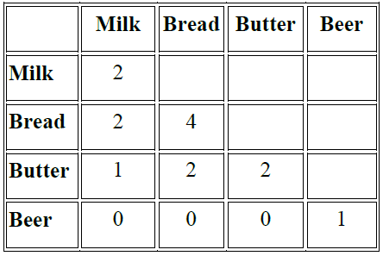

Fig. 7 Co-occurrence table for one way association A->B

VI. CONCLUSION

Thus we have proposed a new system for efficient huge data processing which will help in decision making. The proposed system provides analysis based on customer, product, location, time. This project monitors sales data which plays a pivotal role within a retail organization so that retailers have ability to analyze and use this data to improve retail productivity.

VII. FUTURE WORK

The system can be modified to analyze data in different domains. If we want to improve the efficiency, we can compress the snapshot, the output of Mapper and the output of Reducer. In addition, we can expand the scale of the Hadoop cluster and change the parameters of the cluster.

REFERENCES

[1]. Jing Bi, Zhiliang Zhu, Ruixiong Tian, and Qingbo Wang, 2010 IEEE 3rd International Conference on Cloud Computing (CLOUD), Miami, Florida, pp. 370–377, 2010.
[2]. Wilburt Juan Labio, Hector Garcia-Molina. Efficient Snapshot Differential Algorithms for Data Warehousing.
[3]. Ralf Lammel, Data Programmability Team. Google's MapReduce Programming Model-Revisited[R]. Redmond, WA, USA: Microsoft Corp. 2007.
[4]. Yun Tao Li. Design and Implementation of System Massive Data Processing Based on Hadoop[D]. Harbin: Harbin Institute of Technology, 2009.
[5]. Chuntao Li, Bo Liu. An Improvement on Window Snapshot Differential Algorithm. Computer Applications and Software. Vo1.27, No.4:P.I40- 142. 2010,4.
[6]. Hadoop. http://hadoop.apache.org/common/docs/rO.2I.0/cn/

[7]. Tom White. Hadoop the Definitive Guide. Beijing: Tsinghua University
Press, 201O,5.

[8]. R. Agrawal; T. Imielinski; A. Swami: Mining Association Rules Between Sets of Items in Large Databases",

